# **Name**

# **Muhammad Tayyab Rasheed**

# **Section. 2nd C**

# **Class OOPs**

# **Roll No. F24_634**

# **Submitted to**

# **Sir Jamal Abdul Ahad**

**Question No 1**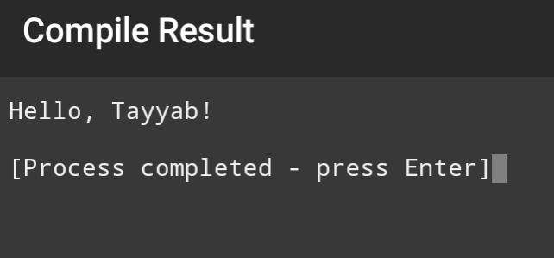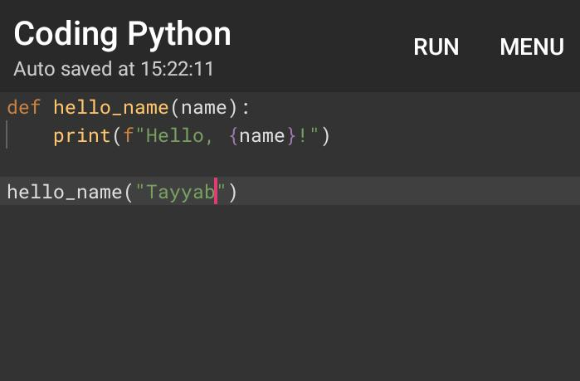

# **Question no 2**

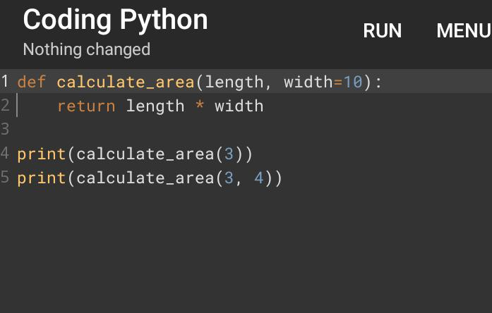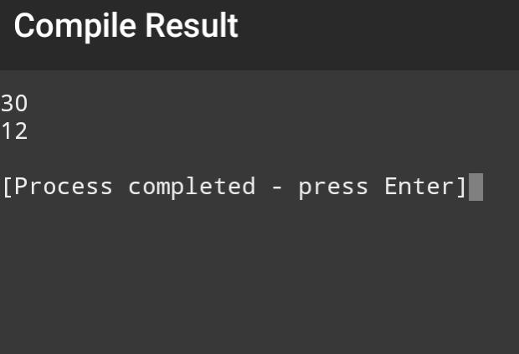

# **Question no 3**

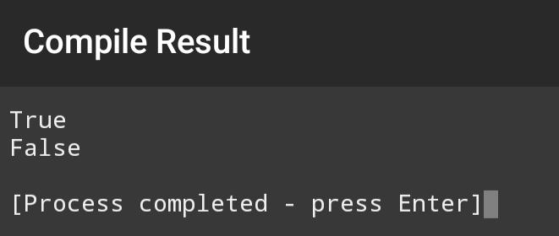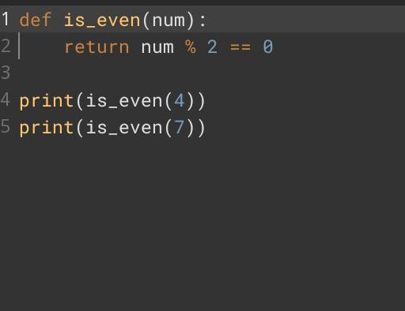

# **Question no4**

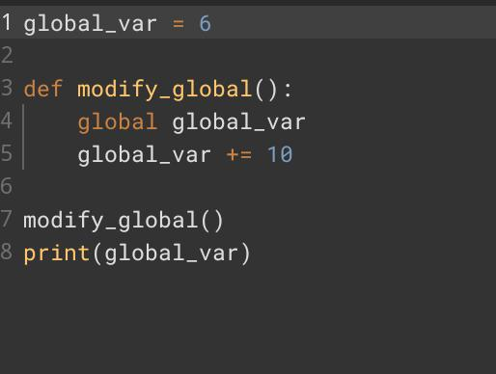

# **Question No 5**

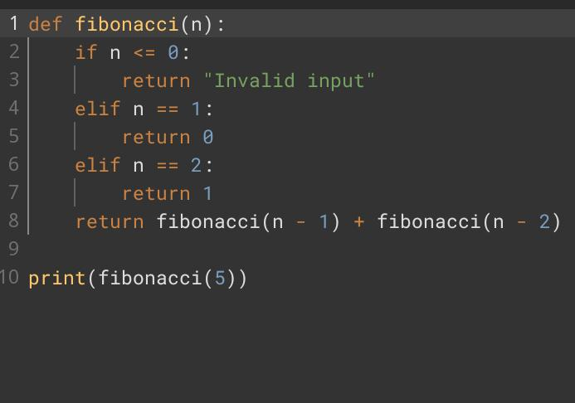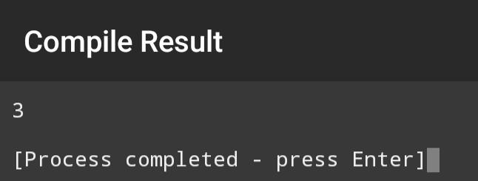

# **Question no 6**

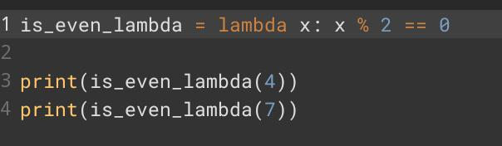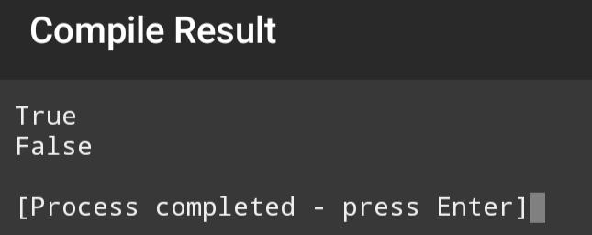

# **Question no 7**

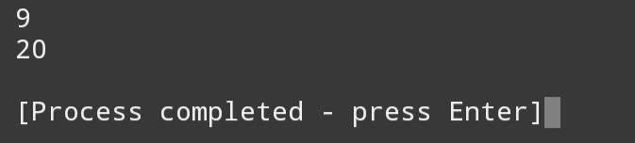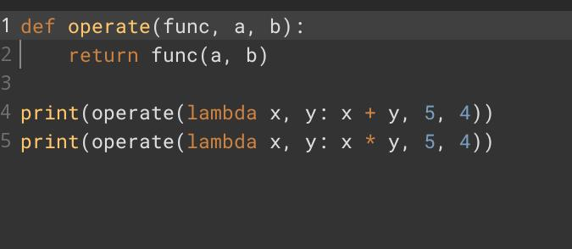

# **Question No 8**

# **Question No 9**